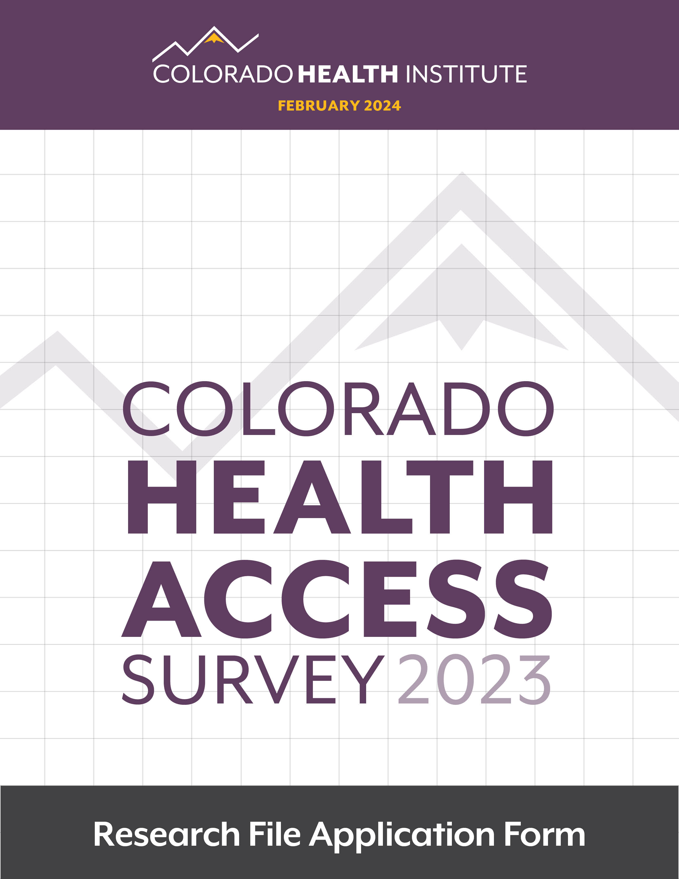

Review Process
Prospective researchers must submit an application to the Colorado Health Institute (CHI) for access to the 2023, 2021, 2019, 2017, 2015, 2013, 2011, and/or 2009 Colorado Health Access Survey (CHAS). Each application will be reviewed by the Colorado Health Access Survey Research Review Committee. Criteria for project approval include the following: feasibility, scope, expertise, risk of disclosure of confidential information, and consistency with the purpose of the CHAS. Researchers are encouraged to develop their proposal in consultation with the staff at CHI.
It will be assumed by the Colorado Health Access Survey Research Review Committee that each application for CHAS data is for one specifically defined research project. If a researcher is interested in conducting several ongoing analyses using CHAS data, the application must specify the intention of the researcher to maintain the data file for long-term use, include the anticipated time period in which the data will be used, and include a description of all projects that will be conducted using CHAS data. Otherwise, the researcher will be required to submit a separate application for each individual project that uses CHAS data.
Upon receipt of an application, CHI will send the prospective researcher an acknowledgement of receipt. The application will be forwarded to the Colorado Health Access Survey Research Review Committee. The committee will review the application and either approve or reject the application or request further information. Applications will be reviewed on a first-come, first-served basis and will be based on the time/date the completed application was received by CHI. The Colorado Health Access Survey Research Review Committee will typically approve, reject, or request further information within 30 days of receipt of the completed application.
If the researcher is requesting county or ZIP-code identifiers, the prospective researcher must also submit a copy of his or her application for review or exemption of the research project by a federally approved Institutional Review Board (IRB), as well as the letter of approval or exemption of the research project from the IRB. The approval letter may be submitted at the time of application or may be submitted any time prior to obtaining access to the data.
Students are also required to provide evidence of faculty sponsorship. Submission of a brief letter from a faculty member stating that he/she is acting as the faculty sponsor/adviser for the project, and that he/she has reviewed and approved the research proposal submitted will meet this requirement.

Data Disclosure Review Committee Role
The Colorado Health Access Survey Research Review Committee is responsible for implementing the confidentiality policies adopted by the Colorado Health Access Survey Advisory Board. Its main tasks include reviewing data files and data requests to ensure that CHAS respondents’ confidentiality is not violated. The committee consists of CHI staff as well as external partners.

Review Criteria
The Colorado Health Access Survey Research Review Committee will use the following criteria to review and evaluate projects:
Feasibility of the project. Can the research question(s) be answered with the available information?
Scope of the project. Does the research design, including the statistical analysis plan, sufficiently address the research question(s)?
Expertise. Is there sufficient evidence that the researcher has the proper resources available to correctly analyze complex survey data?
Risk of disclosure of confidential information. Can the analysis be conducted without compromising the confidentiality promised to respondents?

Review Schedule
The Colorado Health Access Survey Research Review Committee will meet as needed to review all applications requesting use of the CHAS data file and will typically approve, reject, or request further information within 30 days of receipt of the completed application.

Data File
The CHI staff will create custom data files for research projects based on the variables and specifications submitted with the application for access to data. Data files will be supplied to researchers through a secured email attachment or by mailing the researcher a password-protected flash drive through a traceable delivery option. Upon completion of the research project, all CHAS related data files must be permanently deleted from the researcher’s computer system(s), including all portable storage devices (as indicated in the Colorado Health Institute Nondisclosure Affidavit). Researchers must apply for an extension of their project 14 working days before the expiration of the approved use (project end date indicated on page 5). This application should include a summary of the project progress and a new ending date. If the extension application is not received the applicant will be obligated to reapply for use of the CHAS data, or, according to the Colorado Health Institute Nondisclosure Affidavit, destroy all copies of the CHAS data file on his/her computer system(s).

Confidentiality Assurances
Researchers whose proposals to use CHAS data have been approved by the Colorado Health Access Survey Research Review Committee will be asked to sign a Colorado Health Institute Nondisclosure Affidavit prior to receiving access to the data.

Contact Information
Colorado Health Institute
1999 Broadway, Suite 600
Denver, CO 80202
www.coloradohealthinstitute.org
Contact: Lindsey Whittington
Phone: 720.975.9251
Email: whittingtonl@coloradohealthinstitute.org

Colorado Health Access Survey Research File Application Form

Data Files Needed for Analysis (Required)

☐ 2023 Colorado Health Access Survey
☐ 2021 Colorado Health Access Survey
☐ 2019 Colorado Health Access Survey
☐ 2017 Colorado Health Access Survey
☐ 2015 Colorado Health Access Survey
☐ 2013 Colorado Health Access Survey
☐ 2011 Colorado Health Access Survey
☐ 2009 Colorado Health Access Survey
☐ All

Geographic Level Needed for Analysis (Required)
☐ Health Statistics Region and Urban/Rural
☐ County and ZIP Code (requires an IRB approval to be submitted)

Personal and Organizational Information
Project Title:
Principal Investigator (PI): |  | Title: |  |  |  | Degree(s):
Co-investigator: |  | Title: |  |  |  | Degree(s):
Co-investigator: |  | Title: |  |  |  | Degree(s):
PI Organization: |  |  |  | Email:
Address: |  |  |  | Phone:
City, State, ZIP: |  |  |  | Fax:
☐Not Funded ☐ Pending Funding ☐ Pending Funding
Source of Funding:
Project Title:
Project Timeline: | Start: Month_______________ Day_____ Year________  End: Month_______________ Day_____ Year________

Prospective users must submit applications to the Colorado Health Institute at the e-mail address on page 4 of this application. Your application will not be processed until we receive an electronic version (via e-mail) of your application materials (excluding the IRB approval letter and Nondisclosure Affidavit). The Colorado Health Institute Nondisclosure Affidavit and IRB approval or exemption must be mailed or faxed. Complete applications should include the following*:

☐ Cover letter

☐ Completed CHAS Research File application form

☐ A copy of a research or grant proposal, or a description of the research, which includes project purpose, methodology, research questions or hypotheses, statistical analysis plans, and publication plans

☐ Current biographical sketch or resume of principal research personnel. This must demonstrate the ability of the researcher(s) to properly conduct the analysis(es) outlined in the statistical analysis plan

☐ A complete list of the CHAS variables requested (please use the CHAS variable lists provided). Check here if requesting all variables (no list necessary if checked): ☐

☐ A detailed description of any user-supplied data files to be merged with CHAS data, including documentation, file layout, number of records, and restrictions on the use of the data

If you requested ZIP code and county information above, the following should be included with your application:

☐ A copy of the application for review or exemption from a federally approved IRB. An IRB approval is only need if you requested to receive county and ZIP code data above.

☐ Copy of approval or exemption from a federally approved IRB (this must be submitted prior to receiving access to the data but is not required at the time of application). An IRB approval is only need if you requested to receive county and ZIP code data above.

* Students are also required to provide evidence of faculty sponsorship. Submission of a brief letter from a faculty member stating that he/she is acting as the faculty sponsor/adviser for the project, and that he/she has reviewed and approved the research proposal submitted will meet this requirement.

Nondisclosure Affidavit for CHAS
PROJECT#:

The Colorado Health Institute is authorized to provide access to the 2023, 2021, 2019, 2017, 2015, 2013, 2011 and/or 2009 Colorado Health Access data for legitimate research needs. It is also responsible for protecting the confidentiality of respondents. The success of the Colorado Health Access Survey was due to the voluntary cooperation of individuals who provided information to the Colorado Health Access Survey under the assurance that such information would be kept confidential and used only for research purposes.

The Colorado Health Institute requires that all researchers requesting access to the Colorado Health Access Survey data acknowledge that no information may be published or released in a form that identifies an individual or would lead to the disclosure of a respondent’s identity. In addition, all researchers must agree not to share the CHAS data with any party not authorized under this application and to destroy all copies of the data on his/her computer system(s), including all portable storage devices, at the completion or expiration of the research project. By signing this affidavit, the researcher agrees to the terms and conditions of this agreement. Failure to adhere to this affidavit may lead to the prosecution of the researcher under full extent of Colorado law.

In consideration of my request to be granted access to the 2023, 2021, 2019, 2017, 2015, 2013, 2011 and/or 2009 Colorado Health Access Survey data file, I, (please print or type)______________________________, state that I am aware that the information contained in the data file has been provided to the Colorado Health Access Survey with the assurance that it will be used only for health statistical reporting and analysis and will not be published or released in identifiable form. I am also aware that I can be held legally liable for any harm incurred by individuals who have provided or are described in the information contained in the above data file to which I will have access. I also agree not to share copies of the Colorado Health Access Survey data with any party not authorized under this application and to destroy all copies of the data upon completion or expiration of this research project.

Having read and familiarized myself with the Colorado Health Institute Nondisclosure Affidavit, I agree to the terms listed below (please initial each line item).

1. To make no copies of the file or portion of file to which I am granted access.

2. Not to use any technique or method to attempt to learn the identity of any person in the data file.

3. To hold in strictest confidence the identity of any individual that may be inadvertently revealed in any documents, discussion, or analysis. If any such inadvertent revealing of identity occurs, I will immediately bring it to the attention of Lindsey Whittington at the Colorado Health Institute.

4. To acknowledge the Colorado Health Access Survey in a clear and appropriate manner in any publication or other public use of these data. (Acceptable publication notation: 202 Colorado Health Access Survey, Colorado Health Institute, Denver, CO.)

5. To submit copies of any published articles, reports, or briefs based on the Colorado Health Access Survey data to the Colorado Health Institute.

6. To destroy all copies of the Colorado Health Access Survey data on any computer or portable storage device of which I am aware upon completion or expiration of the research project.

Your signature below indicates that you have carefully read and agree to be bound by the above statutory responsibilities. Note that the project’s principal investigator is responsible for the conduct of all associated project staff, including additional guest researchers, programmers, and any co-investigators.

_____________________________________
Principal Investigator Signature Date

_____________________________________
Additional User Signature Date

_____________________________________
Additional User Signature Date

